Artificial Intelligence and Machine Learning

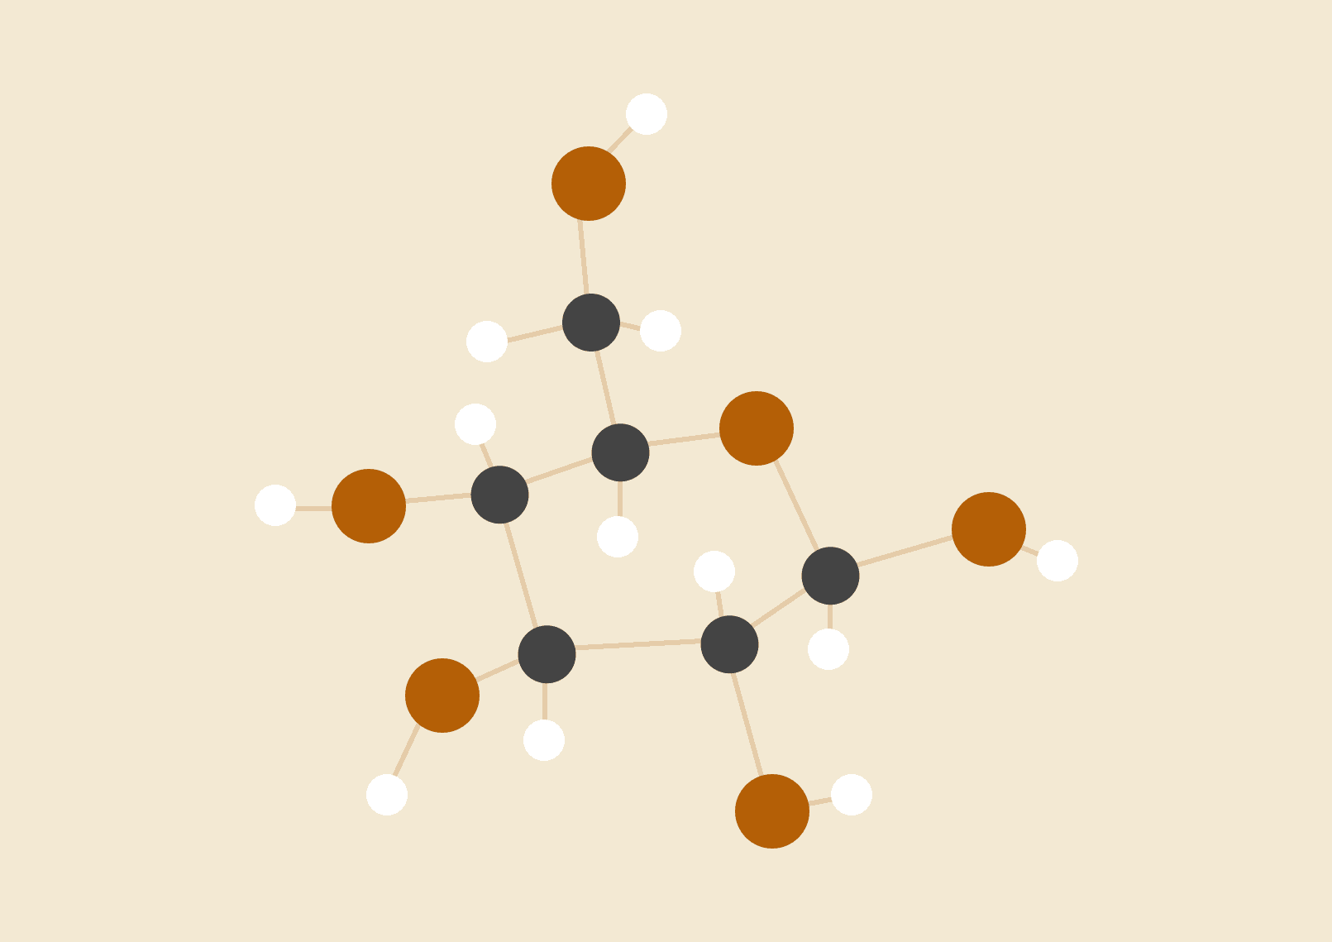

**1.What is the state of the art of this technology?** **1**

**2.What can be done now?** **2**

**3.What is likely to be done soon (say in the next 3 years)?** **2**

**4.What technological or other developments make this possible?** **2**

**2.1What is the potential impact of this development?** **3**

**2.2Which people will be most affected and how?** **3**

**2.3Will this create, replace or make redundant any current jobs or technologies?** **4**

**3.1In your daily life, how will this affect you?** **5**

**3.2What will be different for you?** **5**

**3.3How might this affect members of your family or your friends?** **5**

**REFERENCES** **6**

# 1.What is the state of the art of this technology?

In the 20th century, artificial intelligence and machine learning are gradually gaining popularity. It appears in industries and also in everyday life. Both were created for the purpose of automating work and solving problems faster.

In the industrial field, artificial intelligence and machine learning help calculate data and train machines to work like humans. This greatly helps businesses reduce costs and labor. Especially during the time of covid-19 has helped many businesses overcome difficulties due to high costs(1). Not only that, work performance is improved compared to humans. In addition, in human life, it also contributes to human health care and home comfort. can refer to the system that automatically regulates the indoor temperature. which gives the right temperature for human comfort.

# 2.What can be done now?

Currently, artificial intelligence can act, gesture and express almost like a human. it can: read, speak, write, argue, move, understand emotions,...(2)

# 3.What is likely to be done soon (say in the next 3 years)?

Currently, artificial intelligence is becoming the trend of the whole world. So in all fields, it promises to bring a breakthrough future. Generations and versions are constantly being updated and developed and investors are also spending money to invest in it to create a new step for the future of people.(3) I firmly believe that in the future artificial intelligence and machine learning will be one of the most developed industries because it is an essential need for life and affects people. In a recent study by Cioxhealth, a technology-based health research company, it is using artificial intelligence and machine learning to collect patient data that will provide an opportunity for treatment. disease for cancer patients. They are also building machine learning systems so that machines can communicate with each other to optimize health data.(4)

# 4.What technological or other developments make this possible?

To make the application of AI in healthcare a reality, building a powerful machine learning model and data analysis tools is indispensable.

To meet the strict requirements of safety and confidentiality of patient information, a huge data system and solid security technology are required. so that machines can exchange information and data with each other, the data will be compared and searched for the most accurate way. Data warehouses will be strictly controlled to protect patient information will be done through artificial intelligence. Finally, the data stores will be trained by machine learning models and give the most accurate suggestions for patient diagnosis. Training data will be verified by medical professionals. Early diagnostic data will be displayed through many different data types such as charts, statistical data, …(5)Artificial intelligence will be a doctor's assistant, reducing the burden of working for doctors.

# 2.1What is the potential impact of this development?

Artificial intelligence can have a positive impact on industries especially industries that need continuity or that are dangerous. Dangerous work environments will be replaced by machine learning and artificial intelligence. Jobs related to transportation or computation will be taken care of by AI and machine learning. which helps businesses reduce human costs and optimize profits.(6)

# 2.2Which people will be most affected and how?

Technology brings many benefits to people and makes people's work less burdensome. but its benefits have made many workers fall into unemployment.It can also be said that human labor is threatened by intelligence. In the US, about 20 million - 40 million jobs are gradually being replaced by artificial intelligence, which accounts for 15%-30% of the US workforce.(6) Also in the UK, experts predict more than 7 million jobs will be replaced by machines within the next 10 years.(7)Because the benefits of technology are so great, it is convenience that will work against people. The impact of artificial intelligence does not stop at employment and labor, it also affects economy, society, law and politics. Determining the fault of a car driven by artificial intelligence has caused a lot of controversy about who is responsible and legal.(8)

# 2.3Will this create, replace or make redundant any current jobs or technologies?

In this era, the doctor is one of the demanding and time consuming profession to become a doctor. The current shortage of doctors is increasing, especially during the covid-19 period. To be able to shorten the time and increase the accuracy during surgery. Robot doctors controlled by artificial intelligence and machine learning were born. With algorithms and computer processing speed, computers have become more advanced and have the speed and ability to process more information than humans. especially when working with artificial intelligence and machine learning. Doctors still feel more confident during surgery. Typically, Da Vinci's(9)(10) help is indispensable in surgeries. Its accuracy was already beyond human ability. which allows doctors to perform complex surgeries. Now, artificial intelligence has not been able to completely replace doctors and it is just stopping at the position of an assistant for doctors. But with the level of science growing stronger and stronger, within the next 10 years, it will be artificial intelligence that will be our doctor.

# 3.1In your daily life, how will this affect you?

In my life artificial intelligence and machine learning are all around me a lot. It is indispensable in my life. Currently I am using google assistant as my assistant. It helps me a lot. Every day it automatically announces the weather and reminds me to bring an umbrella when it rains or I often order to remind me when I have appointments. In short, in my life it becomes that part of my life with it I feel life more convenient and quality of life more enhanced.

# 3.2What will be different for you?

Technology has changed the world a lot and my life has been changed to adapt to this world. Artificial intelligence gives me more inspiration to continue researching and pursuing my passion. I think artificial intelligence is the future of human development, so I also need to learn more and explore more, maybe it will help my life be more prosperous. I am starting to have some good ideas for this technology, so maybe in the future I'll create a product of artificial intelligence to improve life in Vietnam.

# 3.3How might this affect members of your family or your friends?

There are many positive benefits that artificial intelligence and machine learning bring, but its benefits are also its downsides. Humans will be too dependent on machines and if one day machines stop working for some reason, our world will become chaotic. we should not be too dependent on it, having to prepare certain scenarios to deal with problems like this. The second thing is that the machine works non-stop without stopping but has high work efficiency. The problem of unemployment is aggravated and many families lose their jobs, resulting in other social problems. so we also need to consider replacing labor with machines

# REFERENCES

(1)<https://www.journalofaccountancy.com/news/2021/may/use-ai-for-cost-optimization-in-manufacturing.html>

(2) <https://www.forbes.com/sites/bernardmarr/2019/11/11/13-mind-blowing-things-artificial-intelligence-can-already-do-today/?sh=90476ce65020>

(3)<https://www.forbes.com/sites/forbestechcouncil/2019/01/16/13-industries-soon-to-be-revolutionized-by-artificial-intelligence/?sh=4e5a58433dc1>

(4) <https://www.cioxhealth.com/>

(5) <https://datavant.com/solutions/life-sciences//>

(6)<https://www.forbes.com/sites/quora/2017/01/18/how-much-will-ai-decrease-the-need-for-human-labor/?sh=1f2998fb75c0>

(7)<https://bernardmarr.com/what-is-the-impact-of-artificial-intelligence-ai-on-society/>

(8)<https://www.investopedia.com/tesla-s-tsla-autopilot-reported-to-cause-another-crash-5199481>

(9)<https://www.forbes.com/sites/saibala/2021/09/22/can-doctors-truly-be-replaced-by-technology/?sh=5302455a4a83>

(10)<https://www.davincisurgery.com/>